**MAWLANA BHASHANI SCIENCE AND TECHNOLOGY UNIVERSITY**

SANTOSH, TANGAIL-1902



DEPARTMENT OF INFORMATION AND COMMUNICATION TECHNOLOGY

**Course Title: Computer Based Numerical Method Lab**

**Course Code: ICT-2102**

**Lab Report on: Guess Elimination.**

**Lab Report No: 05**

|  |  |
| --- | --- |
| Submitted By | Submitted To |
| Name: Kuldip Saha Mugdha  ID: IT-22018  2nd Year, 1st Semester  Session: 2021-2022  Dept. of ICT, MBSTU | Dr. Mst. Nargis Akter  Professor  DEPARTMENT OF INFORMATION AND COMMUNICATION TECHNOLOGY  MAWLANA BHASHANI SCIENCE AND TECHNOLOGY UNIVERSITY |

**Date of Performance:**

# Date of Submission:

**Experiment no:** 05

**Experiment name:** Guess Elimination.

**Objective:** The objective of this lab report is to solve a system of linear equations using the Gaussian Elimination method, implemented in MATLAB.

**Materials:** MATLAB

**Given System of Linear Equations**

The system of equations provided is:

1. 3x1​−0.1x2​−0.2x3​=7.85
2. 0.1x1​+7x2​−0.3x3​=−19.3
3. 0.3x1​−0.2x2​+10x3​=71.4

**Code:**

% Coefficient matrix A

A = [3 -0.1 -0.2;

0.1 7 -0.3;

0.3 -0.2 10];

% Right-hand side vector b

b = [7.85; -19.3; 71.4];

% Augmented matrix [A|b]

Ab = [A b];

% Perform Gaussian elimination (forward elimination)

n = length(b);

for k = 1:n-1

for i = k+1:n

factor = Ab(i,k) / Ab(k,k);

Ab(i,k:n+1) = Ab(i,k:n+1) - factor * Ab(k,k:n+1);

end

end

% Display the upper triangular matrix

disp('Upper triangular matrix after Gaussian elimination:');

disp(Ab);

% Perform back substitution

x = zeros(n,1);

x(n) = Ab(n,n+1) / Ab(n,n);

for i = n-1:-1:1

x(i) = (Ab(i,n+1) - Ab(i,i+1:n) * x(i+1:n)) / Ab(i,i);

end

% Display the solution

disp('Solution vector [x1, x2, x3]:');

disp(x);

**output:**

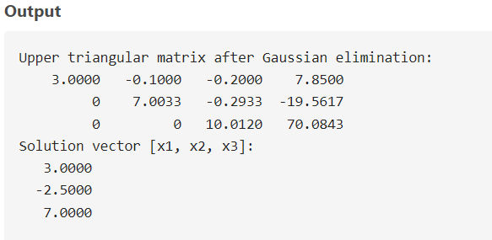

**Discussion:** The Gaussian elimination method was successfully implemented in MATLAB to solve the given system of linear equations. The process involved transforming the coefficient matrix into an upper triangular matrix using forward elimination and solving for the unknowns using back substitution. Gaussian elimination is a robust and systematic approach for solving linear systems, especially for small to moderately sized problems where direct methods are computationally feasible.